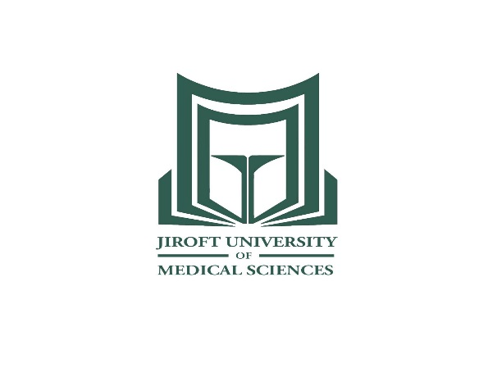

**JMU Curriculum Vitae**

|  |  |
| --- | --- |
| Personal Information |  |
| First Name: Mozhde | C:\Users\toshiba\Downloads\IMG_2695.jpg |
| Surname: Pajokh |
| Gender: Female |
| Marital Status: Single |
| Date of Birth: February 17, 1988 |
| Current Position: Assistant professor, anatomical sciences |
| Address: Jiroft, Iran. |
| Telephone: +983443317802 |
| Fax +983443317802 |
| E-mail : Mpajakh@yahoo.com |
| Education | |
| Ph.D.:  From: Department of Anatomical Science, Faculty of Medicine, Shiraz University of Medical Sciences (SUMS), Shiraz, Iran.  Thesis: Evaluation of Apoptosis, Autophagy and Necrosis in Female Germ-line before and after Birth and Neo-oogenesis in Mouse Ovary. 2013–2018.  M.Sc.:  From: Department of Anatomical Science, Faculty of Medicine, Tarbiat modares University, Tehran, Iran.  Thesis: Evaluation of the Growth of Follicles after Mouse Ovary Organ Culture in the Medium Supplemented with Growth Differentiation Factor-9B (GDF-9B) Using Proliferating Cell Nuclear Antigen (PCNA) Marker. 2011-2013.  B.Sc.:  From: Department of Midwifery, Shiraz University of Medical siences, Shiraz, Iran.  Midwifery student. 2007–2011. | |
| Research Interests | |
| Reproductive biology  Programmed cell death in female murine gonadal development  In vitro female murine gonadal development | |
| Theses (Supervised/Advised) | |
| Project proposal referee   * Evaluation of hydroxylamine and hydrazine derivatives and synthesized chrysine benzamide effect in human breast and liver cancer cells. Number: 220 * Synthesis of hydroxylamine and hydrazine and benzamide christine derivatives. Number:232 * Evaluation of agmatine effect on subventricular adult male mice stem cells post temuzolamide anticancer treatment. Number: 208 * In vitro evaluation of cell death and angiogenesis of human umbilical cord endothelial cells in the presence of different forms of miltefosine. Number: 308 * In vitro evaluation of new busolic acid derivatives effects on human cervical and intestinal cell line growth. Number: 362 * Evaluation of French maritime pine bark extract supplement effect on tumor growth and immunological factors in breast cancer mouse model. Number: 485 | |
| Books | |
| * Embryology textbook. Publisher: Dr Khalili author group. 2011. ISBN: 9789651131011 * Histology textbook. Publisher: Dr Khalili author group. 2014. ISBN: 9786007888827 | |
| Journal Papers | |
| Pajokh M, Mesbah F, Bordbar H, Talaei T. Investigation of different cell death types in the follicular atresia of juvenile mouse ovary. Iranian journal of veterinary research. 2019.  Pajokh M, Talaei T, Bordbar H, Mesbah F. Apoptosis, autophagy and necrosis in murine embryonic gonadal ridges and neonatal ovaries: an animal model. Iranian journal of medical sciences. 2018.  Salehnia M, Pajokh M, Ghorbanmehr N. Short Term Organ Culture of Mouse Ovary in the Medium Supplemented with Bone Morphogenetic Protein 15 and Follicle Stimulating Hormone: A Morphological, Hormonal and Molecular Study. [Journal of Reproduction & Infertil](https://www.ncbi.nlm.nih.gov/pmc/articles/PMC5124338/)ity. 2016.  Pourfridoni M, Pajokh M, Seyedi F. Bladder and bowel incontinence in COVID-19. Journal of medical virology. 2021.  Pajokh M, Pourfridoni M. Proposing a nasal trehalose-induced autophagy approach against SARS-CoV-2. Health science reports. 2021.  Pajokh M, Dalfardi M, Mehralizade M, Seyedi F. Evaluation of upper limb anthropometric measurement of Iranian medical students for estimating sex and stature. Middle east journal of rehabilitation and health studies. .2022   * Evaluation of Covid-19 impression on serum Antimullerian hormone level in recovered reproductive age women and comparision with healthy age matched privates * Evaluation of procarbazine effect on immature mouse ovarian follicles * Sex and stature estimation based on upper limb anthropometric indices in Iranian adult population * Sex and stature estimation based on upper limb anthropometric indices in Iranian adult population * Sex and stature estimation based on lower limb anthropometric indices in Iranian adult population * Evaluation of stature, sex and age based on foot print indices in Iranian adult population | |
| Conference Presentations | |
| Evaluatin of the follicular growth after mouse ovarian organ culture in the medium supplemented with growth differentiation factor-9B. Royan international congresson reproductive biomedicine. September 2013 Tehran.  Journal club. The basic principles of radiological interpretation, Jan 2021 Jiroft medical university.  Database search method, May 2021 Jiroft medical university. | |
| Workshops | |
| Royan international congress on reproductive biomedicine. September 2013 Tehran.  Royan embryology symposium. March 2011 Tehran.  Neural stem cell conference. Razi international conference center. November 2012 Tehran.  Online video conference, the importance of finding and using research in medical education, professor Marcel D Eon, 23 June 2021.  The effect of healthy & harmful foods on human health, 20 April, Jiroft medical university, 2019.  National Conference aging Health, Jiroft medical university. 2021. | |
| Research Projects | |
| * Evaluation of Covid-19 impression on serum Antimullerian hormone level in recovered reproductive age women and comparision with healthy age matched privates * Evaluation of procarbazine effect on immature mouse ovarian follicles * Sex and stature estimation based on upper limb anthropometric indices in Iranian adult population * Sex and stature estimation based on upper limb anthropometric indices in Iranian adult population * Sex and stature estimation based on lower limb anthropometric indices in Iranian adult population * Evaluation of stature, sex and age based on foot print indices in Iranian adult population | |
| Academic and Professional Experiences | |
| Practical anatomy & histology resident teaching medical students, Shiraz university of medical sciences.  Cadaver fixation and dissection, 2014-2015, Islamic azad university Kazeron  Team-based cadaver dissection, Shiraz university of medical sciences.  Cadaver dissection, 2019, Jiroft medical university . | |
| Teaching Skills | |
| Anatomy, Embryology, Histology Lecturer. General Practitioner & bachelor degree education. 2014-2018, Islamic azad university Kazeron  Anatomy & Embryology Lecturer. General Practitioner & bachelor degree education. 2019-2021, Jiroft medical university . | |
| Other skills | |
| RNA extraction  cDNA synthesis  PCR  Real-time PCR  Immunohistochemistry  TUNEL Assay  Preparing & sectioning paraffin embedded tissue  Hematoxylin and eosin staining  Toluidine blue staining  Tissue processing for tansmission electron microscopy  Ultramicrotomy sectioning semithin section  Ultramicrotomy sectioning thin section  Cryostat tissue sectioning  Tissue culture  Organ culture | |
| Scientific Memberships | |
| Iranian student committee of anatomical sciences, Iran university of medical sciences, 2013, Tehran.  Member of publication committee, 2019-2021, Jiroft medical university.  Member of research committee, 2019-2021, Jiroft medical university.  Supervisor of medical education student committee, 2019-2021, Jiroft medical university. | |
| Awards and Achievements | |
| Ranked 1th in tarbiat modares university entrance exam for M.Sc. degree in anatomical science, 2011.  Ranked 1th of graduation in tarbiat modares university for M.Sc. degree in anatomical science, 2013. | |